**Emergent Leaders**

Module for AoE beta release 328 – by azatote

**Rigmora the Forgotten (Hippus, neutral-evil) – Incorporeal**



* level 1: Illusion promotion for mounted units (note: keep in mind that they cannot kill enemies, only damage them), the palace provides Nightmare.
* level 2: Mounted units gain March and Flying.
* level 3: Mounted units gain Fear, all summoned units are considered as mounted units.

Background: the ghost leader of a host of spectral r(a)iders.

Tip to gain leader XP: build a strong cavalry, make them gain XP. As a ghost, Rigmora loves the Summon Spectre spell, the Death and Shadow magic spheres and some resources (Sheut Stone and Nightmare notably); as a Hippus leader, she appreciates cavalry-oriented buildings.

**Detlesias (Amurites, chaotic-evil) - Pyromancer**

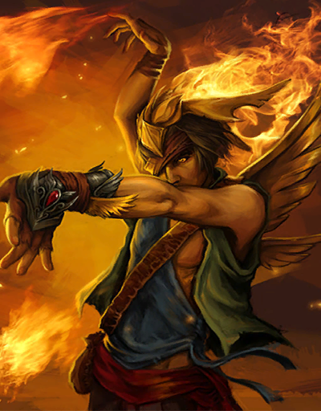

* Level 1: arcane units with fire 2 can cast Ring of Flames. Arcane and melee units gain 30% fire resistance and fire affinity (gives them first strike and defensive strike chances).
* Level 2: arcane units with fire 3 can cast Pillar of Fire. You can cast Ignite Pyre (burn a citizen to make a Pyre Zombie) in your cities.
* Level 3: Arcane and melee units receive an extra 30% fire resistance and an improved fire affinity (gives them collateral damage). Fireballs, Fire Elementals and Pyre Zombies receive +2 fire strength.

Background: a crazed pyromancer who burns down everything and everyone standing in his way.

Tip to gain leader XP: it’s very simple. Build adepts. Train adepts. Burn your enemies and your friends alike.

**Rizuruk (Clan of Embers, neutral-evil) – Matriarch**

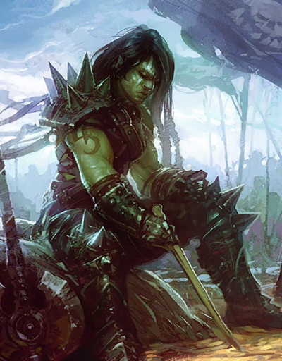

* level 1: - 15 % GP. When Orthus appears, he spawns as a Clan unit.
* level 2: Orthus gains Dimensional 1, heroes gain +1 fire strength.
* level 3: Heroes gain Commander as a secondary unit class (+3 command limit, can get commander promotions) and Battle Command 1

Background: she was an unknown warboss within the Clan, until the day she made the mighty Orthus come to Braduk and swear allegiance to the Clan. Some say she convinced him with her great charisma and persuasion skills, while others whisper that they are secret lovers.

**Angaad (Bannor, lawful-neutral) – Warleader**



* level 1: free promotion Corporal (melee, disciples)
* level 2: commanders gain +1 command limit and give their minions +10% XP gain. Reduced level requirements for the Chain of Command promotions (master sergeant level 4, captain level 6, general level 10).
* level 3: commanders und their minions receive 25% withdrawal chance.

Background: c’mon, haven’t you read her pedia already?